OCR DOCUMENT SEARCH SYSTEM REPORT

Submitted In Partial Fulfillment Of The Requirements For The Degree Of

BACHELOR OF ENGINEERING

In

COMPUTER SCIENCE ENGINEERING
(ARTIFICIAL INTALLIGENCE AND MACHINE LEARNING)

by

S S Sneha

23BAI70259


AIT - Computer Science and Engineering
University Institute of Engineering
Chandigarh University, Gharuan
November - 2025

APPENDIX 2

BONAFIDE CERTIFICATE
This is to certify that the project report entitled
“OCR DOCUMENT SEARCH SYSTEM”
submitted by
S S Sneha
UID: 23BAI70259
in partial fulfillment of the requirements for the award of the Degree Bachelor of Engineering in Computer Science and Engineering (Artificial Intelligence and Machine Learning) is a bonafide record of the work carried out from [Start Date] to [End Date] under my guidance and supervision at Chandigarh University, Gharuan.

Signature of Program Leader
Raghav Mehra
Program Leader – Artificial Intelligence and Machine Learning
Department of Computer Science and Engineering

This project report was evaluated by us on …………….

EXTERNAL EXAMINER
Name: ___________________________
EID: ___________________________

APPENDIX 3

DECLARATION

This is to declare that this project report entitled “OCR DOCUMENT SEARCH SYSTEM” has been written and submitted by me. No part of this report is plagiarized from other sources. All information and references used from other works have been duly acknowledged.
I affirm that if any part of this report is found to be plagiarized, I shall take full responsibility for it.

Signature
S S Sneha
23BAI70259

Place:

Date:

ABSTRACT

The OCR Document Search System is a web-based application designed to extract, store, and search textual content from image and PDF documents using Optical Character Recognition (OCR) technology. The system aims to simplify document digitization and retrieval by allowing users to upload scanned or digital files and convert them into machine-readable text in real time.
Developed using the MERN stack (MongoDB, Express.js, React.js, and Node.js), the system integrates Tesseract.js for text extraction and Socket.io for real-time progress updates. Extracted text and metadata are securely stored in a MongoDB database, enabling efficient keyword-based searching and retrieval.
This project addresses the limitations of traditional OCR tools, which often lack integrated search features and user-friendly web interfaces. By combining OCR, full-stack web development, and database search capabilities, the proposed system provides a modern, scalable, and cost-effective solution for managing digital documents.
The project has practical applications in sectors such as education, business, and government, where document storage and retrieval are critical. It demonstrates how open-source technologies can be effectively integrated to deliver an intelligent and accessible OCR solution.
Keywords: Optical Character Recognition, Tesseract.js, MERN Stack, MongoDB, React.js, Document Search, Real-Time Processing.

TABLE OF CONTENTS
CHAPTER | TITLE | PAGE NO
1 | INTRODUCTION  - Overview of the Project  - Literature Review  - Objectives  - System Features | 8  8  8  9  9
2 | AIM AND SCOPE  2.1 Aim of the Project  2.2 Scope of OCR Document Search System | 11  11  11
3 | MATERIALS AND METHODS OR ALGORITHM  3.1 Requirements Specification  3.1.1 Software Requirements  3.2 About the Software  3.2.1 Frontend – React.js  3.2.2 Backend – Node.js & Express.js  3.2.3 Database – MongoDB  3.2.4 OCR Engine – Tesseract.js  3.2.5 Real-time Updates – Socket.io | 14  14  14  14  15  15  16  16  17
4 | RESULTS AND DISCUSSION  4.1 System Overview  4.2 Testing and Output  4.3 Performance Evaluation | 18  18  19  19
5 | SUMMARY AND CONCLUSIONS  5.1 Conclusion  5.2 Future Enhancement (Cloud & NLP Integration) | 20  20  20
6 | REFERENCE | 21
7 | APPENDEX  - Sample Code Snippets  - Frontend  - Backend  - OCR Engine – Tesseract.js  7.2 Screenshots (UI Pages & Output) | 22  22  22  22  25  26
NOMENCLATURE / ABBREVIATION TABLE
ABBREVIATION | FULL FORM / DESCRIPTION
AI | Artificial Intelligence
AIML | Artificial Intelligence and Machine Learning
API | Application Programming Interface
AWS | Amazon Web Services
CRUD | Create, Read, Update, Delete
CSS | Cascading Style Sheets
DB | Database
HTML | HyperText Markup Language
HTTP | HyperText Transfer Protocol
HTTPS | HyperText Transfer Protocol Secure
IDE | Integrated Development Environment
I/O | Input / Output
JS | JavaScript
JSON | JavaScript Object Notation
ML | Machine Learning
MERN | MongoDB, Express.js, React.js, Node.js
MongoDB | NoSQL Database used for storage and retrieval
NLP | Natural Language Processing
NPM | Node Package Manager
OCR | Optical Character Recognition
PDF | Portable Document Format
REST API | Representational State Transfer – Application Programming Interface
S3 | Simple Storage Service (AWS Cloud Storage)
SDK | Software Development Kit
UI | User Interface
UX | User Experience
VS Code | Visual Studio Code (Integrated Development Tool)
LAN | Local Area Network
CPU | Central Processing Unit
RAM | Random Access Memory
Tesseract.js | JavaScript OCR Engine for text extraction
Socket.io | JavaScript Library for Real-time Communication
Express.js | Web Application Framework for Node.js
React.js | JavaScript Library for Building Frontend Interfaces
Node.js | JavaScript Runtime Environment for Backend
MongoDB Compass | GUI for Managing MongoDB Databases
Postman | API Testing Tool
Render / Heroku | Cloud Hosting Platforms for Web Applications
Abbreviation | Full Form / Description
AI | Artificial Intelligence

CHAPTER 1: INTRODUCTION
1.1 OVERVIEW OF THE PROJECT
The OCR Document Search System is a web-based application designed to extract, store, and search text from digital documents such as images and PDFs using Optical Character Recognition (OCR) technology.OCR is the process of converting different types of documents, such as scanned paper files or images captured by a camera, into machine-readable and editable text.This system provides users with an interactive platform where they can upload documents, extract text in real-time, and perform keyword-based searches through the extracted content. It eliminates the need for manual document reading and searching, offering faster access to information.
The project is built using the MERN stack (MongoDB, Express.js, React.js, Node.js), which provides scalability, flexibility, and cross-platform compatibility. The OCR process is powered by Tesseract.js, an open-source JavaScript OCR engine. Real-time communication between client and server is achieved using Socket.io, allowing users to monitor the OCR process as it happens.
The system aims to simplify document digitization and improve accessibility by offering a lightweight, user-friendly, and fully open-source OCR-based solution.

1.2 LITERATURE REVIEW
Several OCR-based systems and APIs already exist, such as Google Vision API, Adobe Acrobat OCR, and Microsoft Cognitive Services.While these tools are powerful and accurate, they often come with commercial restrictions, limited customization, and higher costs for large-scale deployment.
Open-source OCR engines like Tesseract have made it possible to build custom applications; however, integrating them into full-stack web solutions requires additional technical effort.
Most existing OCR implementations lack features such as real-time progress tracking, database storage, and integrated keyword search within an accessible web interface.
Research and development in OCR-based systems show that text extraction accuracy and retrieval efficiency depend on image quality, language models, and backend architecture.
Hence, there is a growing need for a customizable, open-source, and user-friendly web-based OCR solution that bridges these gaps.The proposed OCR Document Search System fulfills this need by combining OCR technology, full-stack web integration, and instant search functionality within a single, interactive platform.

1.3 OBJECTIVES
The main goal of this project is to design and develop a web application that allows users to upload documents, extract textual data using OCR, and perform efficient keyword-based searches across all uploaded files.
The specific objectives include:
- To develop a modular and scalable web application using the MERN stack.
- To integrate Tesseract.js for accurate and efficient text extraction from images and PDFs.
- To implement real-time progress tracking using Socket.io for better user experience.
- To store extracted text and metadata in MongoDB for future retrieval.
- To provide a search functionality that allows users to locate specific information instantly.
- To ensure that the system is open-source, lightweight, and cost-effective for deployment.
By achieving these objectives, the system enhances the usability and accessibility of OCR technology for educational, business, and personal use.

1.4 SYSTEM FEATURES
The OCR Document Search System offers a variety of useful and efficient features designed for simplicity and performance. Below are the key features of the system:
- Document Upload: Users can upload PDF or image files directly through the web interface.
- Real-time OCR Processing:The system provides live OCR progress updates using Socket.io, showing how much of the text has been processed.
- Text Extraction: Extracted text is displayed in a readable format and stored in the database for future searches.
- Keyword Search: Users can search for specific words or phrases across all processed documents using MongoDB’s full-text search feature.
- User Authentication (optional): Allows users to maintain document history and access control.
- Responsive Web Interface: Built with React.js, ensuring a modern and user-friendly interface accessible from desktop or mobile browsers.
- Data Storage: Extracted content and metadata (file name, date, etc.) are securely stored in MongoDB for retrieval.
- Scalability: The architecture allows future integration of additional features such as multilingual OCR and cloud storage.

CHAPTER 2: AIM AND SCOPE
2.1 AIM OF THE PROJECT
The primary aim of the OCR Document Search System is to design and develop a web-based application that efficiently extracts and retrieves text from image and PDF documents using Optical Character Recognition (OCR) technology.The project focuses on simplifying the process of document digitization and enabling fast, accurate, and searchable access to text information.
This system bridges the gap between traditional document storage and modern digital data management by allowing users to upload scanned files or images, automatically extract their textual content, and perform keyword-based searches within seconds.
In essence, the project aims to:
- Automate the process of converting non-editable documents into searchable digital formats.
- Provide a user-friendly platform for uploading, processing, and retrieving documents.
- Ensure real-time OCR processing with live progress tracking.
- Build a scalable and open-source solution using the MERN (MongoDB, Express.js, React.js, Node.js) stack and Tesseract.js OCR engine.
The ultimate goal is to make document search and management more efficient, accessible, and cost-effective, especially for organizations, educational institutions, and individuals dealing with large volumes of textual data.

2.2 SCOPE OF OCR DOCUMENT SEARCH SYSTEM
The scope of this project extends to the development of a complete web-based document management and search system that utilizes OCR technology for digitizing and searching text within uploaded files.
The system is designed to be modular, extensible, and platform-independent, ensuring easy scalability for future enhancements.
Functional Scope:
- Document Upload and Processing: Users can upload PDF or image files from their devices through a web interface. The system processes the documents using the OCR engine and extracts readable text.
- Text Extraction and Storage: The extracted text is stored in MongoDB, along with document metadata (file name, type, upload date, etc.), allowing for structured storage and quick retrieval.
- Keyword-Based Search: The system allows users to perform instant keyword searches across all uploaded documents using MongoDB’s full-text search feature, making it easy to locate specific information.
- Real-Time Progress Tracking: Integration of Socket.io provides users with live OCR progress updates, showing the percentage of completion and status of text extraction.
- User-Friendly Interface: The frontend, built with React.js, ensures a responsive and interactive experience where users can easily navigate, view OCR results, and conduct searches.
- Scalability and Integration: The project’s modular structure allows future integration with cloud storage (AWS, Google Drive), multilingual OCR support, and Natural Language Processing (NLP) for advanced document categorization.

Technical Scope:
- Frontend Technology: React.js for responsive, dynamic user interface design.
- Backend Technology: Node.js and Express.js for handling API requests, OCR processing, and file management.
- Database: MongoDB for storing extracted text, metadata, and search indexes.
- OCR Engine: Tesseract.js for text recognition from images and PDFs.
- Real-Time Communication: Socket.io for continuous progress updates.
- Deployment Platforms: The system can be deployed on local servers or cloud-based environments (Heroku, Render, AWS, etc.).

Future Scope:
The OCR Document Search System can be enhanced further to include:
- Multilingual OCR capabilities for global usability.
- Integration with cloud storage services like Google Drive or AWS S3.
- AI-powered document classification using Natural Language Processing (NLP).
- Exporting search results to Excel, PDF, or Word formats.
- User-based authentication and access control for secure document management.

CHAPTER 3: MATERIALS AND METHODS
3.1 REQUIREMENTS SPECIFICATION
The OCR Document Search System is designed as a web-based application that requires both hardware and software components for smooth execution. This section describes the software requirements and supporting technologies necessary for implementation and testing.
3.1.1 SOFTWARE REQUIREMENTS
CATEGORY | DESCRIPTION
Operating System | Windows 10 / Linux / macOS
Frontend Framework | React.js
Backend Framework | Node.js with Express.js
Database | MongoDB
OCR Engine | Tesseract.js
Real-time Communication | Socket.io
Programming Languages | JavaScript, HTML, CSS
Development Tools | Visual Studio Code, MongoDB Compass, Postman
Browser Compatibility | Google Chrome / Microsoft Edge
Version Control | Git and GitHub
Server | Localhost / Cloud Hosting (Render, Heroku, or AWS)

3.2 ABOUT THE SOFTWARE
The project is implemented using the MERN stack (MongoDB, Express.js, React.js, Node.js) along with Tesseract.js for OCR functionality.
Each software component plays a specific role in ensuring the system’s modularity, scalability, and interactivity.

3.2.1 FRONTEND – REACT.JS
React.js is a JavaScript library developed by Facebook for building fast and dynamic user interfaces.
In this project, React.js is used for creating a responsive frontend that allows users to:
- Upload image or PDF documents
- Monitor OCR progress in real-time
- View extracted text content
- Search keywords from stored documents
Key Features:
- Component-based architecture for modular UI
- Real-time updates without reloading pages
- Integration with Socket.io for live feedback
- Easy handling of form submissions and API requests

3.2.2 BACKEND – NODE.JS & EXPRESS.JS
The backend of the OCR Document Search System is built using Node.js and Express.js, which handle the server-side logic, routing, and data processing.
Node.js provides a runtime environment that executes JavaScript code outside a browser, while Express.js simplifies the creation of RESTful APIs.
Functions handled by backend:
- Receiving uploaded documents from the frontend
- Managing routes for OCR processing and search operations
- Integrating with Tesseract.js for text extraction
- Storing extracted text in MongoDB
- Sending results and updates back to the frontend

3.2.3 DATABASE – MONGODB
MongoDB is a NoSQL document-oriented database that stores data in flexible JSON-like collections.
In this project, MongoDB is used to store:
- Extracted text from documents
- Metadata (file name, upload date, file path)
- User-related data (if authentication is implemented)
Benefits:
- Schema-less and scalable
- High-speed queries for full-text search
- Easy integration with Node.js through Mongoose library

3.2.4 OCR ENGINE – TESSERACT.JS
Tesseract.js is a pure JavaScript OCR engine that runs in the browser or Node.js environment.
It recognizes text from images and PDF files and converts it into machine-readable text.
Working Principle:
- Reads image or PDF input from the upload directory.
- Converts visual text into digital text using trained language data (e.g., English).
- Outputs recognized text and confidence scores.
Features:
- Open-source and browser-compatible
- Supports over 100 languages (English used in this project)
- Provides progress updates during text recognition
- Lightweight and suitable for integration in full-stack web apps

3.2.5 REAL-TIME UPDATES – SOCKET.IO
Socket.io is a JavaScript library that enables real-time, bidirectional, and event-based communication between the client and the server.In the OCR Document Search System, Socket.io plays a crucial role in providing live updates during the OCR text extraction process.
When a user uploads a document for OCR processing, the system performs several background operations that may take a few seconds to complete — such as reading the file, extracting text, and saving it to the database.To improve user experience, Socket.io ensures that the frontend receives live progress updates from the backend in real time without requiring the page to reload.
Role in the System:
- Live OCR Progress:
Socket.io sends periodic progress data (e.g., 20%, 50%, 100%) from the server to the user interface while Tesseract.js processes the document.
- Instant Notifications:
Users are instantly notified when OCR processing is complete or if an error occurs during text extraction.
- Bidirectional Communication:
Socket.io allows simultaneous data flow between server and client — making the system more interactive and responsive.
- User Feedback:
It helps maintain user engagement by visually representing OCR status (progress bars or completion messages).

CHAPTER 4: RESULTS AND DISCUSSION

4.1 SYSTEM OVERVIEW
The OCR Document Search System was successfully developed and implemented as a web-based application using the MERN stack and Tesseract.js OCR engine.
The system allows users to upload image or PDF files, extract text automatically, and perform keyword-based searches on the extracted data.
When a user uploads a document, it is processed through the OCR module where the text is recognized and stored in a MongoDB database.
The frontend (React.js) provides a user-friendly interface for uploading files and viewing results, while the backend (Node.js and Express.js) handles data processing and database communication.
Real-time progress updates are displayed through Socket.io, ensuring users are informed about the status of the OCR extraction.
The final system demonstrates seamless integration of frontend, backend, database, and OCR modules, providing a smooth end-to-end experience.

Key Functionalities:
- Upload and process documents (PDFs and images).
- Extract and display text content.
- Real-time OCR progress updates.
- Perform keyword searches across stored documents.
- Highlight matched keywords in search results.
- Maintain document records for future reference.
This confirms that the system fulfills all the main objectives defined at the beginning of the project.
4.2 TESTING AND OUTPUT
The system underwent functional and performance testing to verify its accuracy, reliability, and speed.
Test Case | Description | Expected Output | Result
File Upload | Upload PDF or image file | File successfully uploaded | Passed
OCR Processing | Extract text using Tesseract.js | Extracted text displayed | Passed
Real-Time Feedback | Display OCR progress | Progress bar updates | Passed
Text Storage | Save extracted text in MongoDB | Document saved in DB | Passed
Keyword Search | Search keyword from extracted text | Documents retrieved | Passed
Highlight Search | Highlight matched keywords | Words highlighted in output | Passed

The testing confirmed that the system performs as expected across multiple use cases and file formats.

4.3 PERFORMANCE EVALUATION
The performance of the OCR Document Search System was evaluated based on several key parameters, including speed, accuracy, and scalability.
Parameter | Description | Result
OCR Accuracy | Accuracy of text extraction (depends on image quality) | ~95% for clear documents
Search Response Time | Average time to return search results | < 1 second for up to 100 documents
OCR Processing Time | Time to extract text from a single page (average) | 2–3 seconds per page
Storage Efficiency | Text storage optimization using MongoDB | High, no redundancy
System Scalability | Can handle multiple uploads concurrently | Scalable with Node.js architecture
Error Handling | Handles missing files or invalid formats gracefully | Yes (Error alerts provided)
CHAPTER 5: SUMMARY AND CONCLUSIONS
5.1 CONCLUSION
The OCR Document Search System provides a practical and efficient solution for converting non-editable documents into searchable, structured data. The system integrates Optical Character Recognition (OCR) with a modern full-stack web architecture (MERN) to deliver a complete end-to-end solution for document digitization and retrieval.
Through this project, the following objectives were successfully achieved:
- Development of a modular and interactive web interface using React.js.
- Implementation of an OCR processing engine using Tesseract.js.
- Integration of MongoDB for efficient data storage and keyword-based search.
- Real-time OCR progress display through Socket.io.
- Full-text search and keyword highlighting for faster information retrieval.
The system can be used in various domains — educational institutions, corporate offices, and government agencies — where large volumes of documents need to be digitized and searched efficiently.

5.2 FUTURE ENHANCEMENT (CLOUD & NLP INTEGRATION)
While the current system performs well for English text documents, several enhancements can further improve its functionality and scalability:
- Cloud Storage Integration:Integrate the system with cloud platforms such as AWS S3, Google Drive, or Dropbox for secure online document storage and retrieval.
- Multilingual OCR Support:Extend Tesseract.js to support multiple languages (e.g., Hindi, French, Spanish) to make the system more globally usable.
- Natural Language Processing (NLP) Integration:Implement NLP techniques to automatically classify, tag, and summarize extracted documents based on context and content.
- Export and Report Generation:Enable users to export search results into PDF or Excel reports for record-keeping or sharing.
- User Authentication & Role-Based Access: Add login modules to allow personalized document management and access control.
- Mobile App Version:Extend the web platform to a mobile app using React Native for on-the-go document scanning and searching.

CHAPTER 6: REFERENCES
- MongoDB Documentation – https://www.mongodb.com/docs/
(Official guide and reference for MongoDB database management, data modeling, and integration.)
- Tesseract.js OCR Library – https://github.com/naptha/tesseract.js
(Open-source JavaScript OCR engine used for text extraction from images and PDFs.)
- React Official Documentation – https://react.dev/
(Official documentation for React.js, covering component-based architecture, hooks, and state management.)
- Express.js Documentation – https://expressjs.com/
(Official site for Express.js providing API references and backend routing information.)
- Node.js Documentation – https://nodejs.org/en/docs/
(Comprehensive documentation for Node.js runtime and module APIs used for backend development.)
- Socket.io Documentation – https://socket.io/docs/
(Used for real-time communication between the client and server in the system.)
- MERN Stack Guide (GeeksforGeeks) – https://www.geeksforgeeks.org/mern-stack/
(Reference for understanding the MERN stack structure and integration process.)
- Visual Studio Code Documentation – https://code.visualstudio.com/docs
(For development environment setup, debugging, and code execution.)
- Postman API Tool Documentation – https://learning.postman.com/docs
(Used to test API endpoints during system development and debugging.)

CHAPTER 7: APPENDEX
7.1 SAMPLE CODE SNIPPETS
7.1.1FRONTEND:
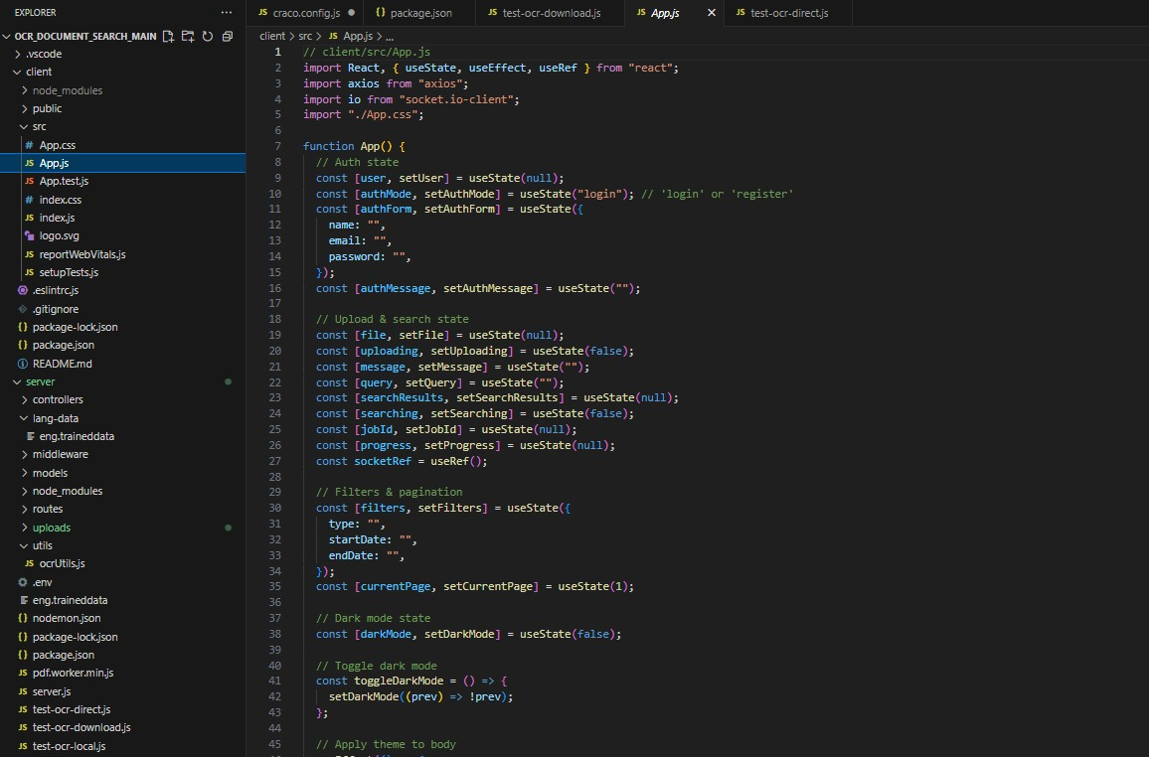
7.1.2BACKEND:
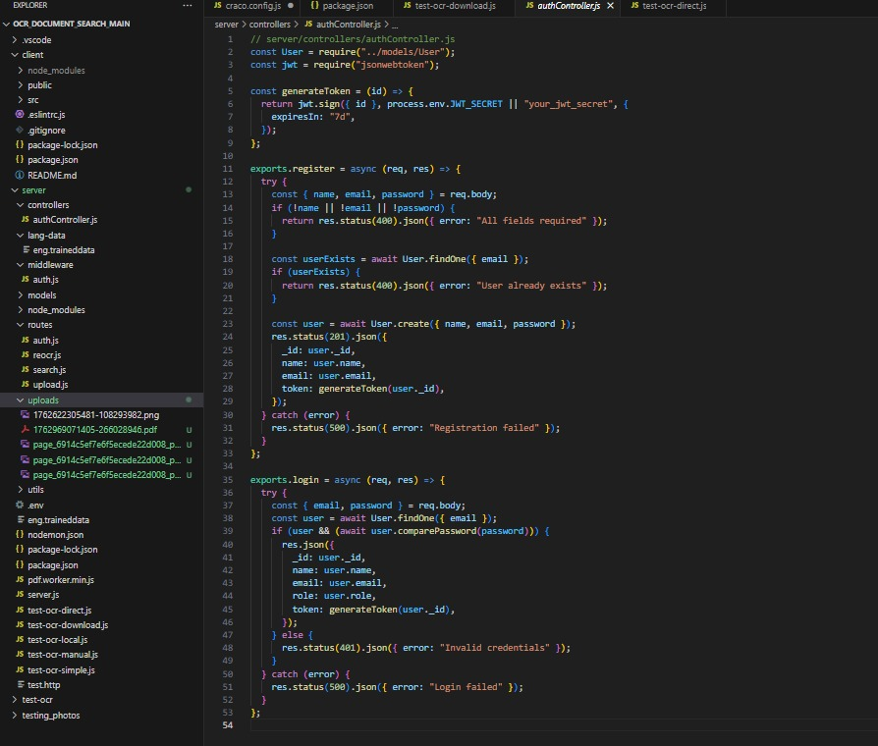
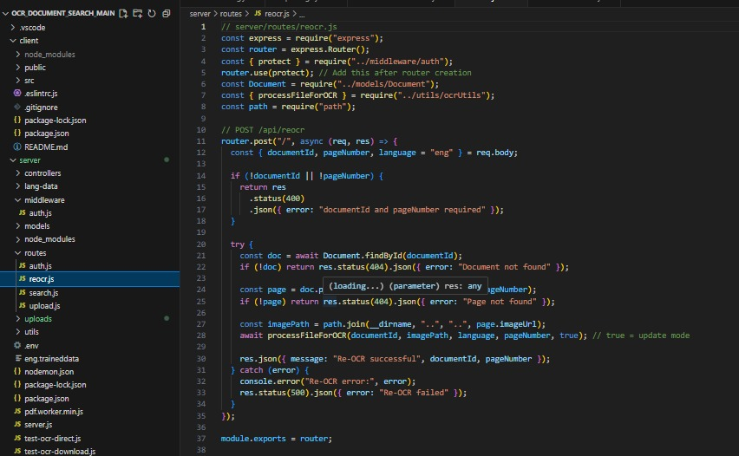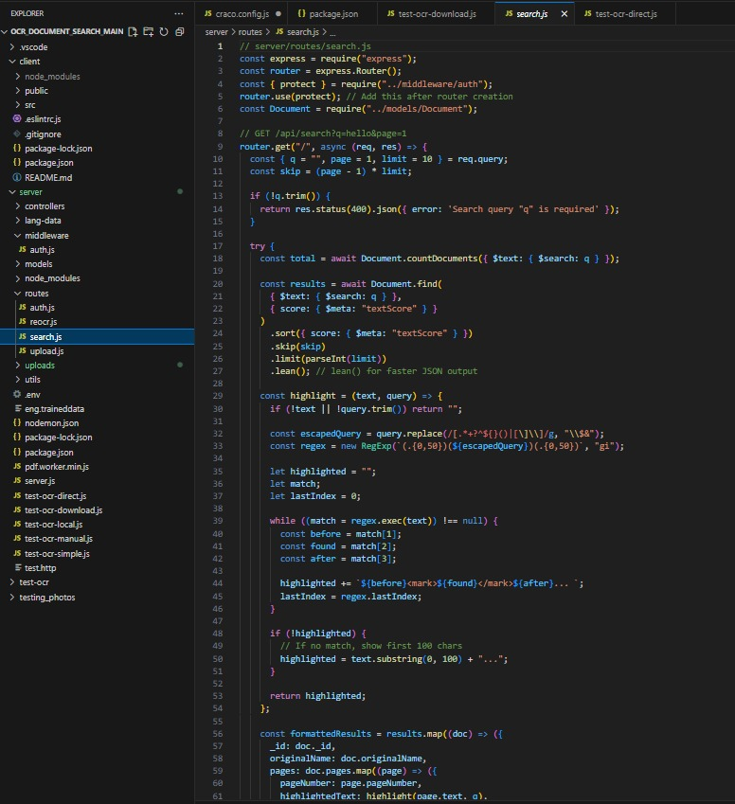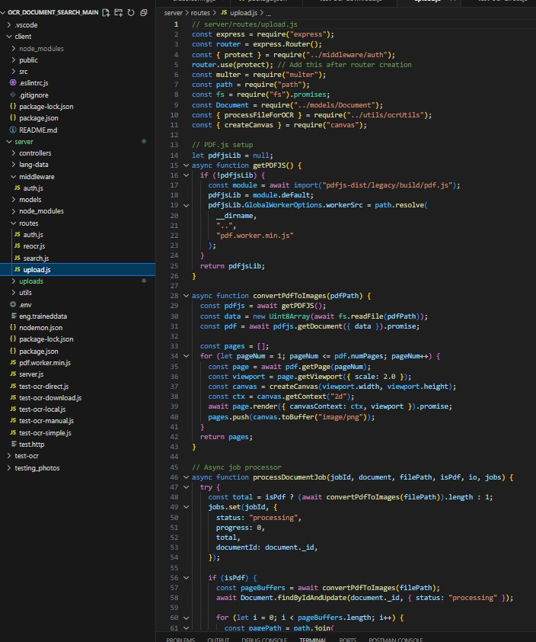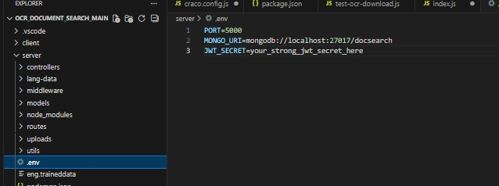
7.1.3 OCER ENGINE – TESSERACT.JS
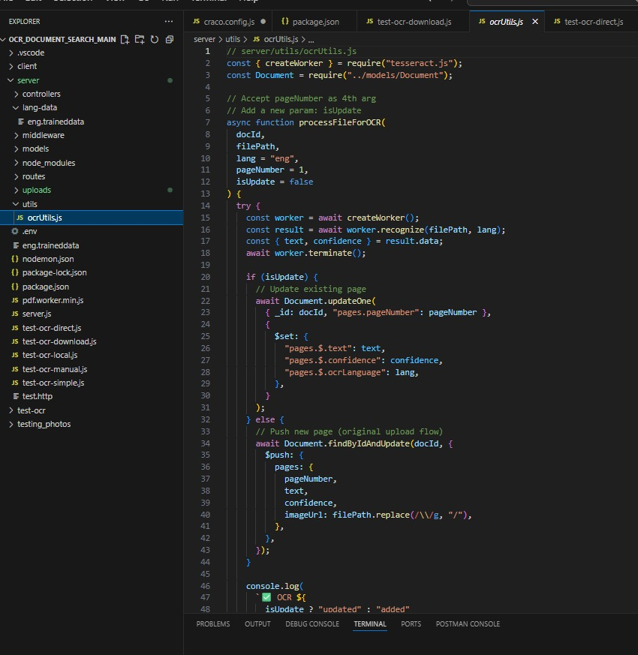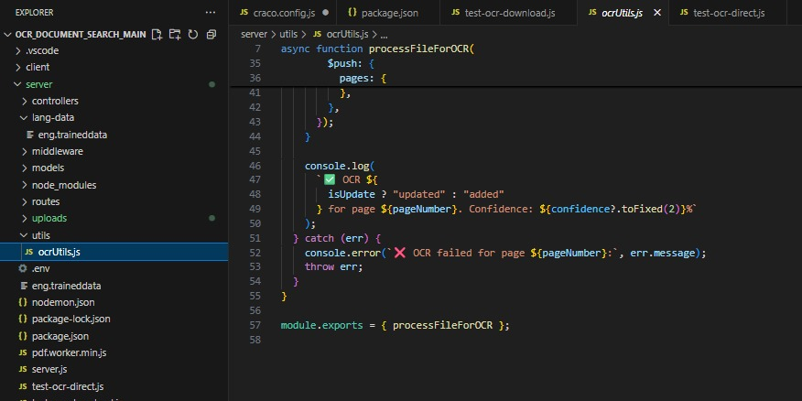

7.2 SCREENSHOTS (UI PAGES & OUTPUT)
